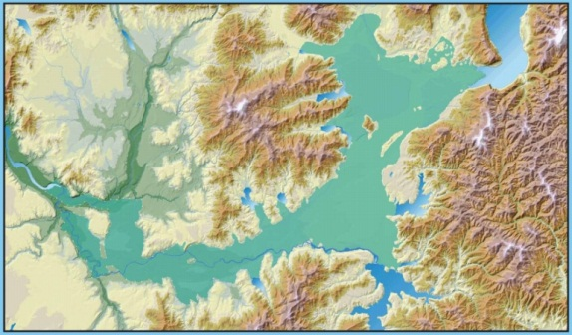
IWAC
Idaho Washington
Aquifer Collaborative
President Mike Galante; VP Ty Wick; Secretary Bryan St. Clair; Treasurer Alan Miller

Idaho Washington Aquifer Collaborative - Logo Contest

The Idaho Washington Aquifer Collaborative (IWAC) invites everyone, of all ages, to put your design skills to work for a regional non-profit. IWAC is in need of a logo that represents collaboration between drinking water and waste water purveyors in the states of Idaho and Washington. Our goal is to protect our “sole source” of drinking water, the Spokane Valley Rathdrum Prairie Aquifer and the Spokane River. IWAC’s purpose and goals are summarized on the back.

Logo Criteria
- Only original artwork will be accepted.
- The logo will incorporate the full name, Idaho Washington Aquifer Collaborative and the acronym IWAC
- Protection of the Aquifer and River are understood by the design.
- Logo is readable and clear when sized for a business card & letter head.
Logo Entry Submission and Rights
- Logo Submission Deadline is Monday, March 31, 2014
- The winning logo (s) will be announced by April 15, 2014
- Artwork may be submitted by mail to
2160 West Dakota Ave. Hayden, ID 83835-5122
- Electronic submissions may be sent to info@spokaneaquifer.org
- Logo artwork becomes the property of IWAC upon submission.
- IWAC reserves the right to alter the original work
Acknowledgement and Prizes
- All submissions will receive a thank you letter of acknowledgement.
- Winning logo designer(s) will be acknowledged with a photo and press release submitted to all local papers throughout the region; on the Spokane aquifer website and in the Spokane River Forum e-news.
- An award letter for your art portfolio and future projects will be presented to acknowledge your contribution to protecting our aquifer and river.
- The winning artist will receive a $100 VISA card. If two designs are selected each artist will receive $50.

IWAC PURPOSE

The purpose of the Idaho Washington Aquifer Collaborative (IWAC) is to work together to maintain and/or enhance water quality and quantity for present and future generations by developing management strategies which benefit the Spokane Valley Rathdrum Prairie Aquifer (as defined by the USGS, “the Aquifer”) and the Spokane River region. IWAC will facilitate regional dialogues and studies that result in recommendations for policy directions and shared stewardship of the Aquifer and the Spokane River, in a collaborative manner.

IWAC GOALS
The objective of developing management strategies is to address regional water supply and demand needs over the next 50 to 100 years. The specific goals of IWAC are organized within the categories of organization, water quantity, conservation, water quality, and public awareness and education. The entire set of goals can be found at http://www.spokaneaquifer.org/idaho-washington-aquifer-collaborative/purpose-goals/

IWAC appreciates your participation in our logo contest.
Please provide the following information with your logo design entry.
Name:
Address:
School or Business Name (optional)
Phone Number:
e-mail Address:
Submit your original design by Monday, March 31, 2014
Mail to:
IWAC Logo Contest
2160 West Dakota Ave.
Hayden, ID 83835-5122

Or e-mail to info@spokaneaquifer.org

The IWAC logo design winner(s) will be announced by April 15, 2014

